Invoice Booking with TDS (at Invoice)

S.NO. : 01- FI-AP- 08

TRANSACTION CODE : FB60

ACCESS PATH :SAP Easy Access Accounting Financial
Accounting Accounts Payable Document Entry
Invoice

Note: If the particular vendor who has to be invoiced/paid doesn’t exist, we need to go to SAP Easy Access Accounting Financial Accounting Accounts Payable Master Data Create or TRANSACTION CODE : FK01 and create a vendor.

We get “Vendor Invoice Enter” Screen as under;

Required Fields:

Vendor To be entered
Invoice Date To be entered
Posting date Default
Reference To be entered (eg:Invoice Number)
Amount To be entered
In the following table select the particular expense G/L Account and enter the amount of the invoice. Incorporating the above fields the invoice will be as under;

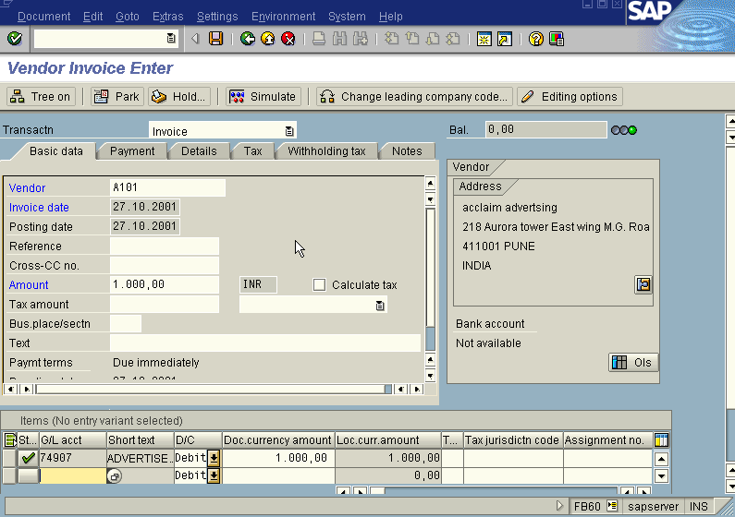

Press Enter Icon

The system gives the message as under

In the above screen press the with holding tax push button and in that screen enter the amount in which TDS has to be deducted. The new screen will be displayed as under:
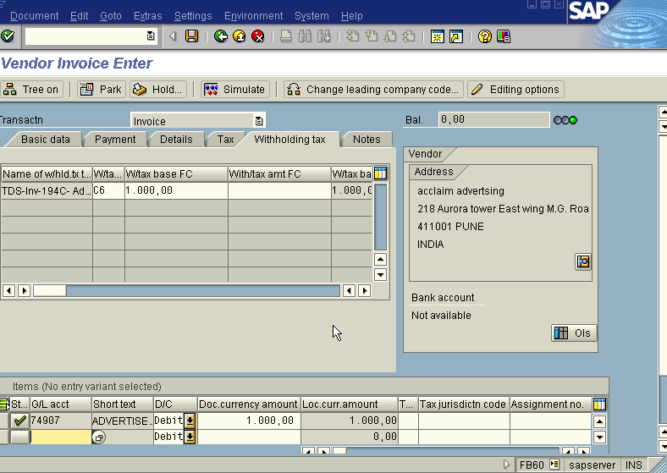

Press Enter icon

Press Save icon

We get the message as under

Take a note of this above number : 1900024

To see the following entries passed go to the main screen “Vendor Invoice Enter”
Document Display or FB03. we get the “Document Overview” Screen as under;

